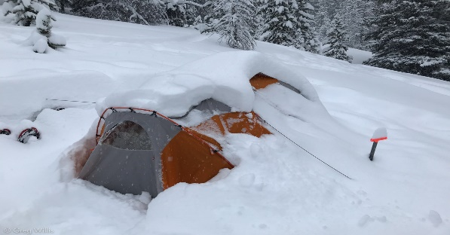
Winter (Snow) Camp
Alexandra Falls Recreation Site. Callaghan Valley.
February 16 – 18, 2024
Questions and Answers for Leaders….
What Guiding level is this camp?
Pathfinders, Rangers and Trex who are interested in learning how to camp safely in the snow and who have not attended Winter camp before. And most importantly, Leaders who are keen to learn all about Winter camping.
What are the camp pre-requisites?
Girls and leaders must have at least 7 nights experience of sleeping in a tent either with Girl Guides or family. It does not have to be consecutive nights. This camp is most definitely not suitable for girls and leaders who have not camped in a tent before.
What is the goal of this camp?
Apart from having a ton of fun, the goal is to provide Leaders and girls with the skill and confidence to camp safely in wintery conditions. Consider it a training camp to prepare Leaders to take girls to future Winter camps independently and an opportunity for girls to expand their confidence in outdoor camping skills. Leaders may come individually or bring interested girls from their Unit.
Where will the camp be located?
Alexandra Falls Recreation site. Alexandra Falls is a recreation site located just before the Callaghan Valley Cross Country Ski area. As you drive north on the Sea to Sky Highway, turn left onto Callaghan Valley Road (the turning is approximately 3 km past Brandywine Falls Provincial Park). The recreation site is on the left and approximately 10 to 15 mins drive up this road. Note: there is no indoor shelter available. There is an outhouse.
What time does camp start and finish?
Starts at noon on Friday Feb. 16 (yes girls will have to miss school and leaders take a day off work) and ends at noon on Sunday Feb. 18.
How is the camp organized?
This will be a bridging event attended by girls and Leaders from different Units within Lions Area. You may sign up as an individual leader or you may sign up with some or all interested girls from your Unit. Depending on numbers, you may be teamed up with other girls and Leaders to form a Unit of about 10 – 15 girls and Leaders. As a Unit, and with guidance from trainers, you will prepare for this camp as you would for any other camp. You will decide on cost, menu, transport to camp, First Aider, who is sharing tents, etc. You will also bring a patrol box with kitchen utensils, camp stoves and fuel. Once we know who and how many are coming to camp (by registration deadline) we’ll set you up with your Unit for Winter camp. We (trainers) will provide lots of guidance and support through the prep process and actual camp.

Could camp be canceled?
Yes. If road conditions are unsafe for driving or we have freezing rain creating a high hypothermia risk.
Who are the trainers and what are their responsibilities?
The trainers for this camp are Tamsin Guppy and Clare Lakes. Both have had lots of experience with Winter camping.
As soon as we know who is coming to camp (by January 12 registration dead line), we will connect with you individually and address any questions you may have…..or, feel free to call Clare at the contact number below if you unsure whether to register or not. After connecting with you, we will arrange to meet with you and your girls as a group to review the Kit List, remind you how to pack, what to bring, not bring, how to put up a Winter tent and generally address any questions that you, your girls or their parents may have. Parents will be invited to this meeting. Both girls and parents can get a bit anxious about Winter camp for different reasons and it’s important that we address these anxieties prior to camp.
About a week before camp we’ll meet again and do an equipment check. Each girl and Leader will bring their packs and sleeping gear all packed and ready to go to camp. We will check to make sure everyone has the right and sufficient gear to manage safely at camp.
At camp, we will show you how to camp in the snow and we’ll take charge of all the (between eating) activities.
What’s the cost?
Each unit will determine the cost of their camp. Alexandra Falls Rec Site is free. The main costs come from food and fuel.
How do I get there and back?
We’ll leave it to you to arrange car pooling with your girls, parents and other Leaders.
Where do I get Winter tents from?
We (trainers) will provide the Winter tents and snow pegs.
How will I know what to bring?
We will give everyone a kit list. We will send you one upon registration. We will also give each Leader(s) of a Unit a gear/equipment list. This is a list of the additional stuff you will need to run your camp i.e. estimated fuel needs, fire grate, wood for under camp stoves, tarps, rope etc. etc. We will work with you to ensure you have gathered everything on the list prior to camp.
What about paperwork?
Good news for you! We will put all the relevant paperwork together and ask you to ensure that it is signed by parents etc. We will need a copy of all the signed paperwork including access to “need to know” relevant health information for girls and leaders.

What happens if a girl is sick or recently recovering from an illness?
Winter camp takes a lot of energy and is not a restful place to recover. We recommend that you and your girls come to camp in very good health and stay home if sick or recently recovering.
How do I register?
Register through Lions Area Training at lionsareatraining@gmail.com Deadline to register is midnight January 06/23.
More questions? Feel free to contact Clare, Camp Advisor, at clarelakes@telus.net or 604 537 6690

